How to debug Atompm ?

Here we are using Visual Studio code to debug Atompm code.

Step1: Start the “httpwsd.js” file from terminal.

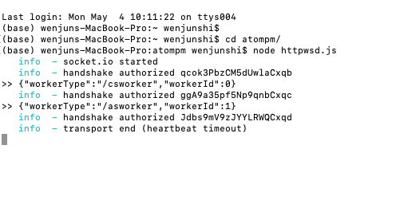

Step2: Open Atompm from browser.

Step3: Set breakpoint in the source code.

Here is an example:

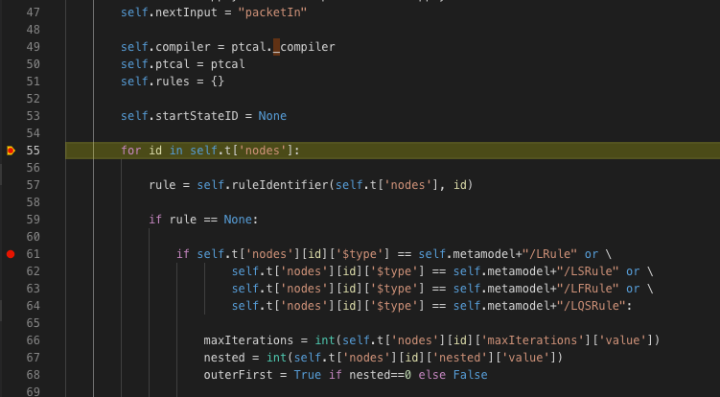

In example, I set two breakpoints in the motifcontext.py file.

Step4: Start debugging from the main.py file.

-go to main.py file

-start debugging under that file.

Step5: Go to Atompm browser, hit the breakpoint from there.

In the example, it will hit the breakpoint when loading a transformation file.

So, In the browser,

-open a sample bird model

- load transformation T_run.model.

Then it will go to visual studio code and stops at the first breakpoint we set.

Step6: Check attributes of the transformation.

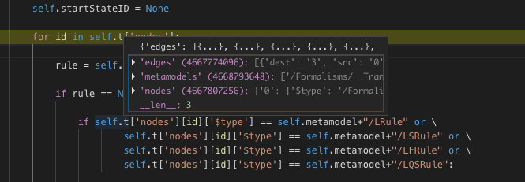

When your hang over t[“nodes”], you will see more info about the transformation.